**Problem Statement: The Doomed Dice Challenge**

**Part-A (15-20 Minutes):**

1. **How many total combinations are possible? Show the math along with the code!**

**Code:**

def doomed_dice_challenge ():

die_a = [1, 2, 3, 4, 5, 6]

die_b = [1, 2, 3, 4, 5, 6]

total combinations = 0

for face_a in die_a:

for face_b in die_b:

total_sum = face_a + face_b

print(f"Die A = {face_a}, Die B = {face_b}. Sum = {total_sum}")

total_combinations += 1

print(f"Total Combinations: {total_combinations}")

doomed_dice_challenge()

**Output:**

Die A = 1, Die B = 1. Sum = 2

Die A = 1, Die B = 2. Sum = 3

Die A = 1, Die B = 3. Sum = 4

Die A = 1, Die B = 4. Sum = 5

Die A = 1, Die B = 5. Sum = 6

Die A = 1, Die B = 6. Sum = 7

Die A = 2, Die B = 1. Sum = 3

Die A = 2, Die B = 2. Sum = 4

Die A = 2, Die B = 3. Sum = 5

Die A = 2, Die B = 4. Sum = 6

Die A = 2, Die B = 5. Sum = 7

Die A = 2, Die B = 6. Sum = 8

Die A = 3, Die B = 1. Sum = 4

Die A = 3, Die B = 2. Sum = 5

Die A = 3, Die B = 3. Sum = 6

Die A = 3, Die B = 4. Sum = 7

Die A = 3, Die B = 5. Sum = 8

Die A = 3, Die B = 6. Sum = 9

Die A = 4, Die B = 1. Sum = 5

Die A = 4, Die B = 2. Sum = 6

Die A = 4, Die B = 3. Sum = 7

Die A = 4, Die B = 4. Sum = 8

Die A = 4, Die B = 5. Sum = 9

Die A = 4, Die B = 6. Sum = 10

Die A = 5, Die B = 1. Sum = 6

Die A = 5, Die B = 2. Sum = 7

Die A = 5, Die B = 3. Sum = 8

Die A = 5, Die B = 4. Sum = 9

Die A = 5, Die B = 5. Sum = 10

Die A = 5, Die B = 6. Sum = 11

Die A = 6, Die B = 1. Sum = 7

Die A = 6, Die B = 2. Sum = 8

Die A = 6, Die B = 3. Sum = 9

Die A = 6, Die B = 4. Sum = 10

Die A = 6, Die B = 5. Sum = 11

Die A = 6, Die B = 6. Sum = 12

Total Combinations: 36

>

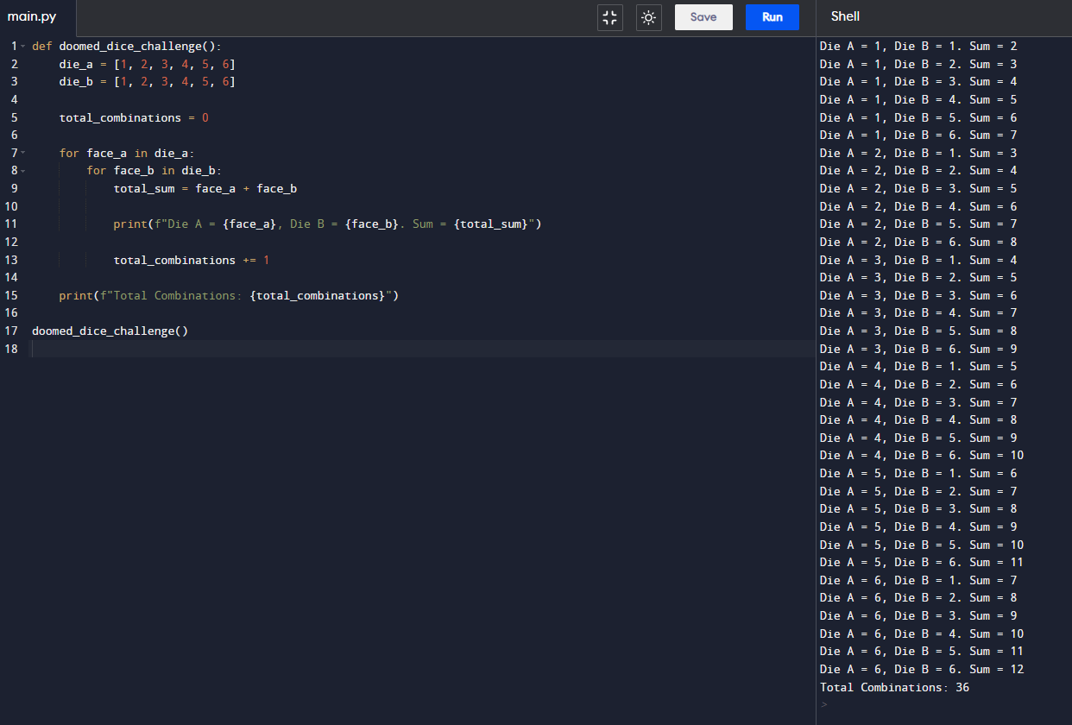

**2. Calculate and display the distribution of all possible combinations that can be**

**obtained when rolling both Die A and Die B together. Show the math along with**

**the code!**

**Code:**

def doomed_dice_challenge():

die_a = [1, 2, 3, 4, 5, 6]

die_b = [1, 2, 3, 4, 5, 6]

distribution_matrix = [[0] * 6 for _ in range(6)]

for face_a in die_a:

for face_b in die_b:

total_sum = face_a + face_b

distribution_matrix[face_a - 1][face_b - 1] += 1

print(f"Distribution Matrix:")

for row in distribution_matrix:

print(row)

doomed_dice_challenge()

**Output:**

Distribution Matrix:

[1, 1, 1, 1, 1, 1]

[1, 1, 1, 1, 1, 1]

[1, 1, 1, 1, 1, 1]

[1, 1, 1, 1, 1, 1]

[1, 1, 1, 1, 1, 1]

[1, 1, 1, 1, 1, 1]>

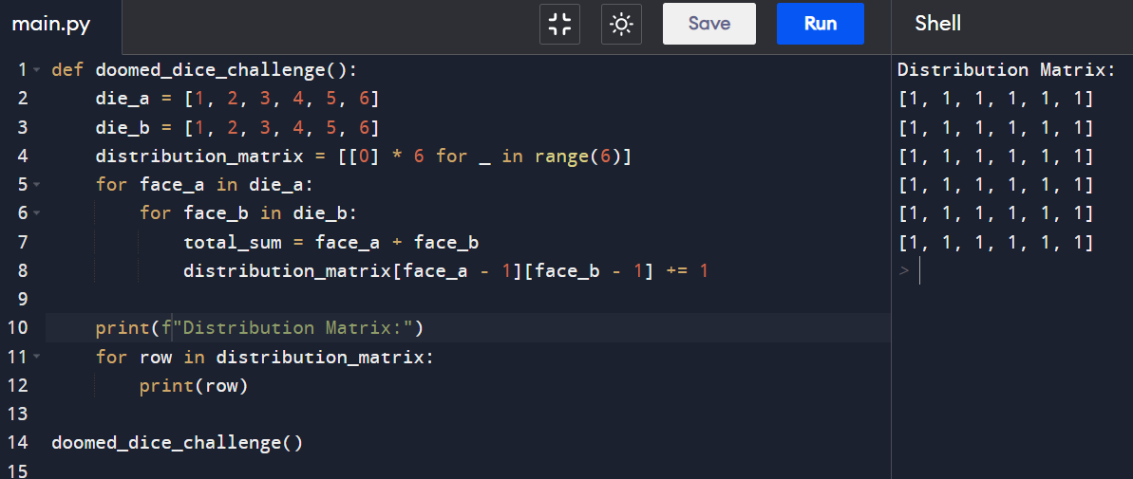

3.**Calculate the Probability of all Possible Sums occurring among the number of**

**combinations from (2).**

**Example: P(Sum = 2) = 1/X as there is only one combination possible to obtain**

**Sum = 2. Die A = Die B = 1.**

**Code:**

def doomed_dice_challenge():

die_a = [1, 2, 3, 4, 5, 6]

die_b = [1, 2, 3, 4, 5, 6]

distribution_matrix = [[0] * 6 for _ in range(6)]

probabilities = {}

total_combinations = 0

for face_a in die_a:

for face_b in die_b:

total_sum = face_a + face_b

distribution_matrix[face_a - 1][face_b - 1] += 1

total_combinations += 1

if total_sum not in probabilities:

probabilities[total_sum] = 1

else:

probabilities[total_sum] += 1

print(f"Probabilities:")

for key, value in probabilities.items():

probability = value / total_combinations

print(f"P(Sum = {key}) = {1/total_combinations} (1/{total_combinations})")

doomed_dice_challenge()

**Output:**

Probabilities:

P(Sum = 2) = 0.027777777777777776 (1/36)

P(Sum = 3) = 0.027777777777777776 (1/36)

P(Sum = 4) = 0.027777777777777776 (1/36)

P(Sum = 5) = 0.027777777777777776 (1/36)

P(Sum = 6) = 0.027777777777777776 (1/36)

P(Sum = 7) = 0.027777777777777776 (1/36)

P(Sum = 8) = 0.027777777777777776 (1/36)

P(Sum = 9) = 0.027777777777777776 (1/36)

P(Sum = 10) = 0.027777777777777776 (1/36)

P(Sum = 11) = 0.027777777777777776 (1/36)

P(Sum = 12) = 0.027777777777777776 (1/36)

>

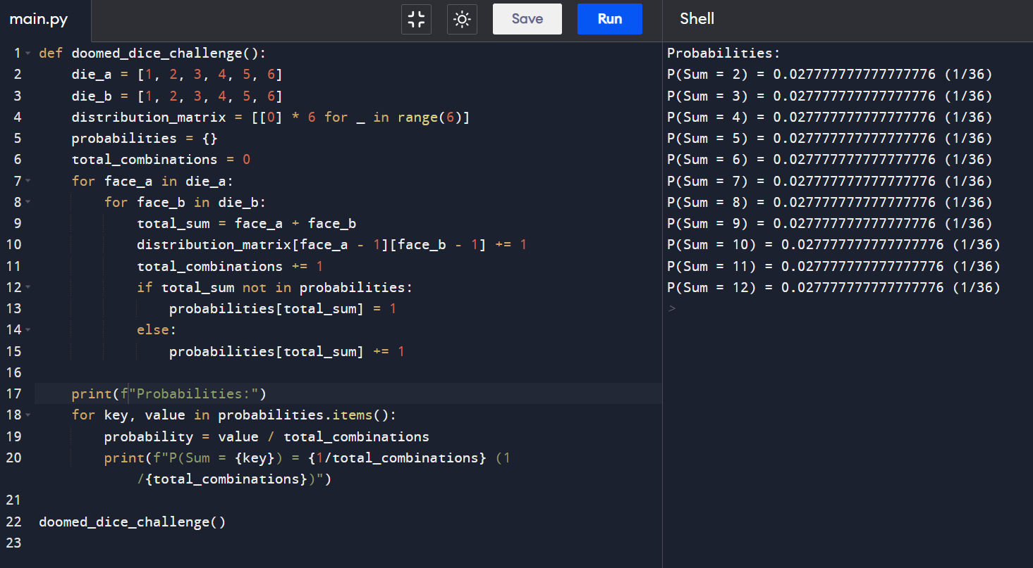

Part-B (25-30)

**Code**:

def undoom_dice(die_a, die_b):

new_die_a = [min(4, x) for x in die_a]

new_die_b = die_b

return new_die_a, new_die_b

die_a = [1, 2, 3, 4, 5, 6]

die_b = [1, 2, 3, 4, 5, 6]

new_die_a, new_die_b = undoom_dice(die_a, die_b)

print(f"\nInitial Die A:", die_a)

print(f"Initial Die B:", die_b)

print(f"\nNew Die A:", new_die_a)

print(f"New Die B:", new_die_b)

**Output:**

Initial Die A: [1, 2, 3, 4, 5, 6]

Initial Die B: [1, 2, 3, 4, 5, 6]

New Die A: [1, 2, 3, 4, 4, 4]

New Die B: [1, 2, 3, 4, 5, 6]

>

